

Name:__________________

Computer Science Semester Review

**This packet is due prior to taking the final**

1. Perform the following calculations in binary

01010011 01001101 01110100

+01100011 +01101010 +01110010

1. Convert the following binary numbers to decimal
   1. 0 1 0 0 1 1 1 0
   2. 1 0 0 1 0 0 1 1
   3. 0 0 0 0 0 1 1 0
   4. 0 0 1 0 1 0 1 1
2. How many bits are in a byte?
3. What is the number of bits needed in order to represent the number 101 in binary?
4. What happens if the distance to the alarm clock is greater than 10?

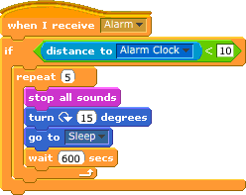

* 1. All sounds stop c. turn 15 degrees
  2. Wait 600 seconds d. nothing

1. Matching - What will the code print?

print type(1.2) <type ‘str’>

print type(‘abc’) <type ‘int’>

print type (45) <type ‘float’>

1. What will the code print?

x = ‘I’

y = ‘luv’

z = ‘computers’

print x+y+z

1. I luv computers
2. Iluvcomputers
3. x+y+z
4. Error- cannot concatenate ‘str’ and ‘int’ objects
5. What will the code print?

x=True

y= False

z= False

if x or y:

print “Sandwich time!”

else:

print “No sandwich time!”

1. What will the code print?

x=True

y= False

z= False

if x and z:

print “Hello There!”

else:

print “Print me!”

1. In[ ]: range(10)

Out[ ]: ?

1. In[ ]: range(100, 125, 5)

Out[ ]: ?

12. What will be the output?

In[ ]: for x in range (0,10):

print x+7